Anne Wall Thomas: North Carolina Artist with a Bauhaus Heart
©2024 Will South

Anne Thomas believed art played a pivotal role in the lives of those who made it, and those willing to engage it. This belief, simultaneously aspirational and yet clear-eyed, propelled a life-long career of creation focused on elevating the idea of art as possibility, and that anything was possible.
This grand notion—that art is about the possible—remains central to the equally grand idea of “modernism” wherein the modern artist questions the conventional and pursues alternatives and innovations. Anne was introduced to modernism while a student at Woman’s College (now the University of North Carolina at Greensboro) studying under the influential Gregory Ivy, founder of that institution’s art department and of the Weatherspoon Art Museum. Under his tutelage, the young artist was introduced to a veritable smorgasbord of crucial concepts: the power of using less to say more; that human experience was valid subject matter; that rules were not made to be broken as much as challenged, interrogated, and amended. Anne drank deeply from this life-changing well of possibility and her dream of an artistic career was affirmed.
These principles not surprisingly echo Bauhaus principles: Gregory Ivy brought Josef Albers himself, formerly a key professor at the Weimar Bauhaus before coming to Black Mountain College in 1933, to Woman’s College to talk to students and answer their questions. Anne listened to Bauhaus concepts declaring that art should make use of new materials; be accessible to all people; and be simplified whenever possible. It was not long before she went from listening to doing, and the Bauhaus aesthetic (via Ivy) would remain integral to Anne’s production.
Worth noting is that during Anne’s student years, a number of women studying at Woman’s College at mid-century went on to become artistic leaders in North Carolina. Maud Gatewood’s art became the visual equivalent of Southern Gothic literature with its brilliant narratives. Lee Hall took the radical implications of abstraction expressionism into softer, more poetic realms than it had yet seen. It was Anne Thomas, though, who most thoroughly and convincingly carried forward the Bauhaus promise of artistic experience with simplified means.
Early in the 1950s, Anne produced Linear Composition with Color, a bold image that checks any number of Bauhaus boxes: it is a print, a medium dear to the heart of the artist willing to inexpensively share; it makes efficient use of the three primaries—red, yellow and blue (from which all other colors are made)—each given a geometric shape outlined in black; and prompts the viewer to envision color and line as architecture. Indeed, this early success is a visual rhyme for a city skyline.
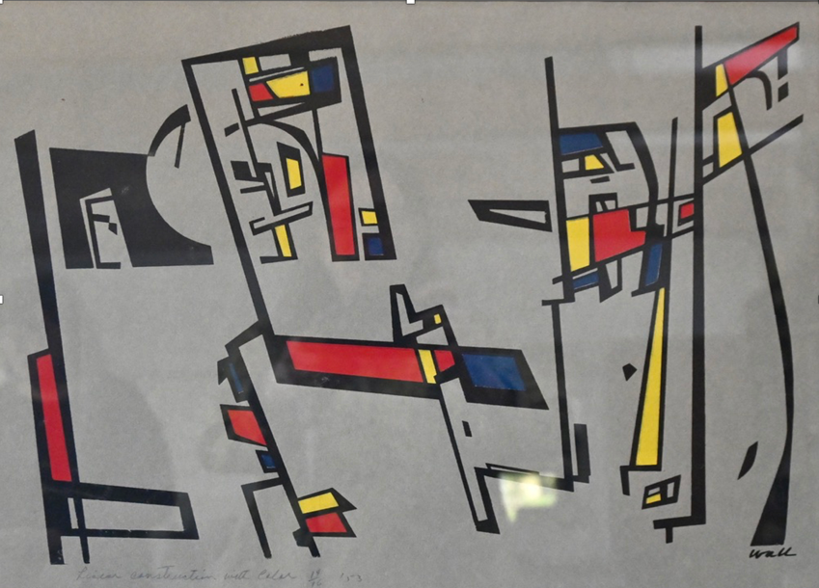
Linear Composition with Color, Estate of Anne Wall Thomas

But Anne’s inventiveness did not end there. She has mischievously embedded letters of the alphabet into her composition, a striking early use of word as image in this region. At the left, the first construction is an “l,” followed closely by a clear letter “e” attached to it, upper right side. The next complex shape is designed to disguise a large letter “a,” crossed at its center with a horizontal red band. It is not too difficult to see the following two letters, an “r” with its second leg of yellow, with the final “n” known with its stylized rounded hump. She has said to us: “Learn.”
Look closely, and you will learn. Clever, yes. Nonetheless, a pointed reward for careful investigation. That is the message of this work made during a time when she was still defining her artistic identity. She could imagine, maybe even enjoy, the thought that some viewers would one day suddenly decipher this image, and smile. It is a positive message.
One may easily imagine, too, that this sort of high-energy design, however striking, was anathema to the then-prevailing aesthetic (far from dead in the 21st century) that demanded a wholesome adherence to nature whether a landscape, portrait or still life.
These would not be subjects for Anne Thomas. Her focus on the possibilities of working with a limited palette and geometric shapes only intensified over the decades. Into the 21st century, she remained busy exploring the composition using basic practices. In The Way to There, we again see, over half a century after Linear Composition, the use of primary colors to drive the visual image. Here, she has added green, a color sometimes referred to as a “psychological primary” as it so often feels fundamental.
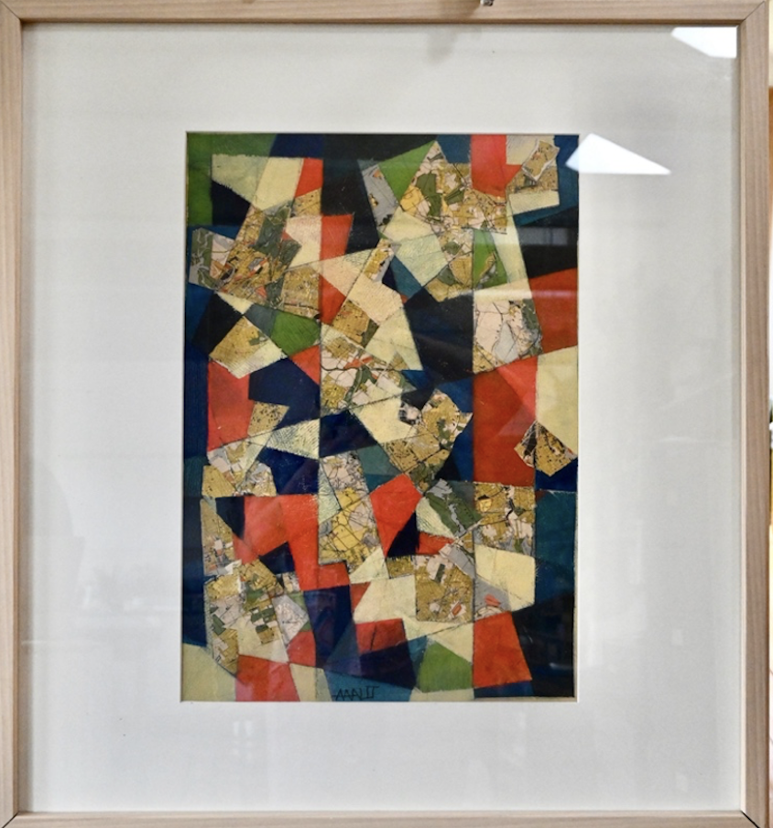
The Way to There, 2015, acrylic on paper, size. Blowing Rock Art and History Museum.

The title of this work, The Way to There, suggests Anne may again be hiding a puzzle—in this case, a map. She is not. Instead, her message has matured. Shapes and colors, she is suggesting to the viewer, are close cousins to alphabets, linguistics and yes, puzzles. Instead of producing a given word (even an important one, such as “learn”) is no longer the point; rather, the point is that a composition of color and shape alone can produce mood. It may produce a feeling of energy, of movement. The reward for contemplating such an image is being enlivened in the moment. The artist provides the opportunity for a moment of invigoration, of sheer positivity. Feeling, she is saying, is good. To feel is to experience life as it is happening. To offer up such experiences was, for Anne, both a privilege and a responsibility. To the end, she was a Bauhaus artist in spirit and deed, while remaining the always interesting individual artist she was.
It may be too soon to characterize the legacy of Anne Wall Thomas, as we live in a world of rapid and often shocking change. Her work, however, is fraught with relevance for our times: Be open to possibility. Make and experience art as part of living. Feel the positivity of simple solutions.
And, learn.

